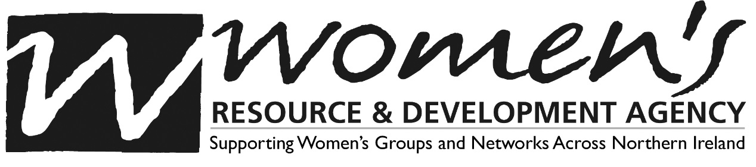

NOMINATION FORM

Candidate’s Declaration and Consent Form

I [insert name] declare that I am not disqualified from acting as a charity trustee of any charity for any of the reasons or on any of the grounds listed in section 86(1) of the Charities Act (Northern Ireland) 2008. These disqualifications broadly include but are not limited to anyone who:
- has been convicted of an offence involving deception or dishonesty, unless the conviction is a spent conviction under the Rehabilitation of Offenders (NI) Order 1978
- is an undischarged bankrupt or has made an arrangement with creditors
- has previously been removed as a trustee by the Charity Commission Northern Ireland or by the courts
- is subject to disqualification under company legislation.

I also give my consent for my name to be recorded in minutes of Committee meeting and my details to be held in a membership register and reported to Companies House, as required by the Charities Act (Northern Ireland) 2008 and Companies Act 2006.

I understand that I have the right to see any data WRDA hold on me. WRDA take data protection seriously and will ensure all personal data is stored securely. The information you provide will be shared with funders, statutory bodies and staff.

Signature ___________________________ Date __________________

