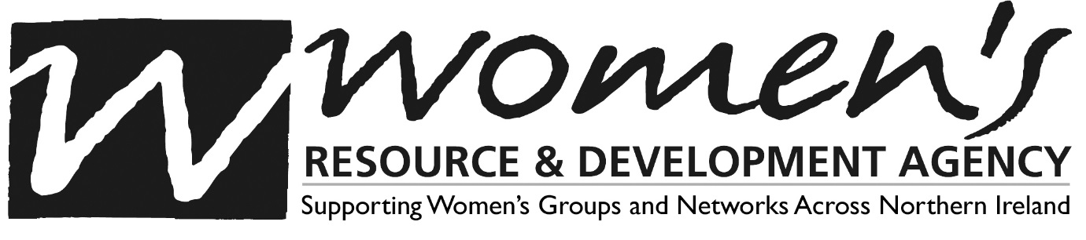
WRDA is a regional organisation whose mission is to advance women’s equality and participation in society by working to transform political, economic, social and cultural conditions. The organisation was established in 1983 and works with women’s groups from both traditions and new communities in the most disadvantaged urban and rural areas of NI.
WRDA’s vision is of a fair and equal society where women are empowered and are a visible force for change and influence in all areas of life.
WRDA’s Strategic Aims 2020-2025 are:
- Empowerment & Tackling Inequalities
- Policy & Advocacy
- Leadership & Infrastructure Support
- Organisational Development

We are seeking new Volunteer Board Members to join a diverse and committed Trustee Board working co-operatively at governance and strategic level to oversee the management and development of the organisation. The Trustee Board brings together women from a range of backgrounds, skills and experience, who are working to meet challenges and opportunities in a changing environment.
We invite applications from women with experience in one of the following areas:
- Employment law & practice
- Industrial relations
- Marketing & PR,
- Risk Management
- Corporate/sponsorship fundraising
- Tender Writing
Previous experience in governance of an organisation is preferable but not essential.
A commitment and willingness to work within the vision, mission and ethos of Women’s Resource and Development Agency are essential.
We strive to create a diverse and inclusive organisation and welcome applications from all women and in particular, we encourage applications from black and minority ethnic communities, LGBTI community, people with a disability and those aged under 40 years.
Trustees will need to commit to 10 meetings per annum which includes meetings usually held on Thursdays from 4.30pm-7pm, attendance at the AGM and strategy development days. Although this role is a voluntary role, travel expenses can be reimbursed.
If you are interested in applying, please visit our website to download the application pack. Applications must be received by close of business on Friday 3rd April and interviews will take place w/b 20th April 2020. Please email applications to the Director (anne.mcvicker@wrda.net).

