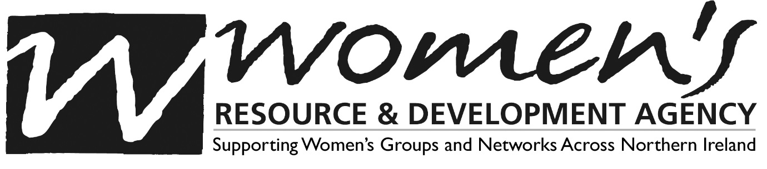

MANAGEMENT COMMITTEE APPLICATION FORM

Name: ___________________________________________________________________

Please tick if you are coming onto the Board as an individual or representing an organisation. If you tick organisation please name:

Individual

Organisation Name of organisation: __________________________________________

Below is a list of the areas of skills/expertise required by WRDA Management Committee members, please tick which areas of skills/expertise you can bring to WRDA’s Management Committee:

- Strategic/Operation Planning ____
- Budgeting/Financial Management ____
- Fundraising ____
- Chairing ____
- Employment Issues/Practices ____
- Evaluation & Monitoring ____
- Legal Awareness ____
- Management ____
- Project Development ____
- Grassroots women’s Perspectives ____
- Research/Lobbying/Policy ____
- Equality & Human Rights ____
- Health ____
- Education/Training ____
- Communications ____
- Media Informally and Formally ____
- Promotion & Marketing ____
- Childcare ____
- Rural issues ____
- Other ____
Please Detail: ____________________________________________________________

Referring to the list above, please write a short paragraph detailing your skills and experience and how they will be beneficial to WRDA.

In your role as Board member how will you work towards the realisation of WRDA’s Strategic Aims and Ethos and Values?

