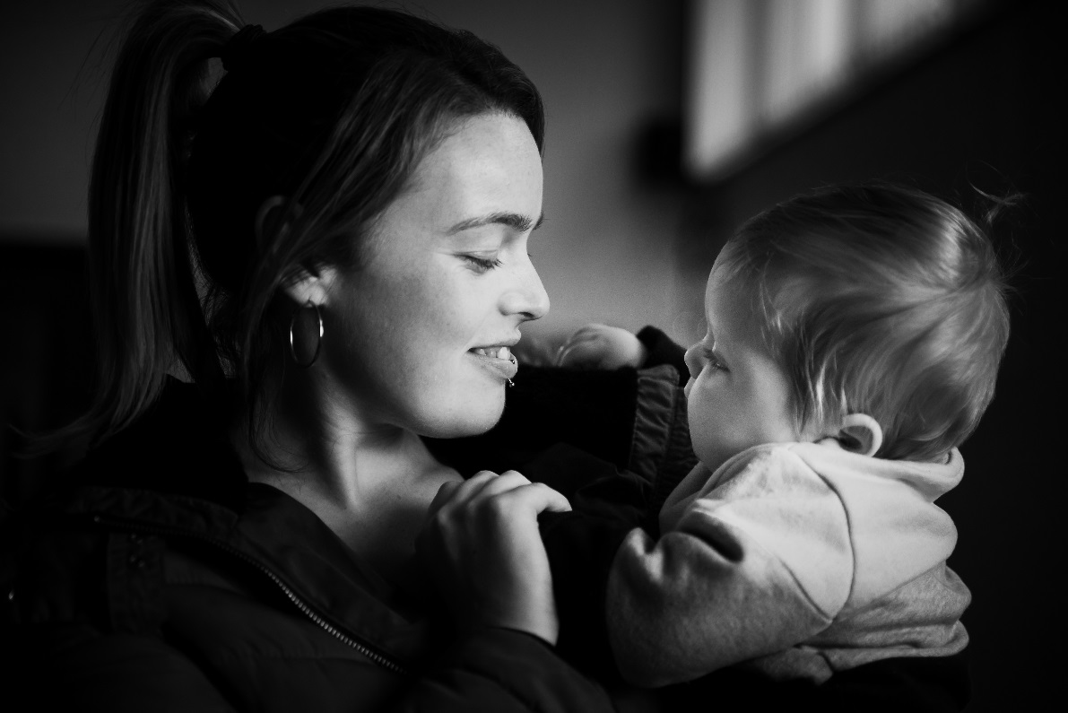

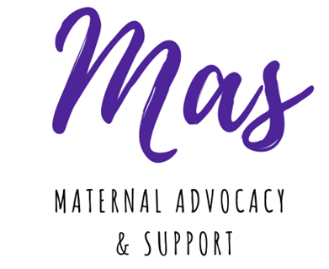

Promoting Positive Perinatal Mental Health through Women’s Centres Evaluation of Pilot Project
July 2019

Introduction
This report is an internal evaluation of the work of Women’s Resource and Development Agency (WRDA) on the issue of perinatal mental health. WRDA is a membership organisation that supports the work of grassroots women’s organisations in disadvantaged and rural areas. Our vision is of a fair and equal society where women are empowered as a visible force for change in all areas of life.
The community based women’s sector, primarily made up of women’s centres, work on a holistic basis to meet the needs of women and promote their participation in decision making and public life. In response to feedback from workers on the ground in women’s centres, WRDA’s Women’s Sector Lobbyist began working on the issue of perinatal mental health in 2017. Work to date has progressed from sign-posting and awareness raising activities, capacity building training and a pilot peer support and advocacy programme called the Mas Project. The focus of this report is on the experiences of participants in the Mas Project, the impact of this pilot and the scope for building on this work in the future.
Report compiled by Kellie Turtle, Women’s Sector Lobbyist, who also coordinated the Mas Project. Kellie is grateful to all the women who participated in Mas for their commitment to the project, their bravery in sharing their stories and the welcome they showed her and their fellow participants. Special thanks go to the workers in each women’s centre who recruited and supported the women who took part. These are Helen Smyth (Greenway), Sharon Gallagher (Footprints), Joan Mercer (Shankill), Gillian McCarroll and Aimee Pinnons (Ballybeen) and Eleanor Jordan, Martina, Julie and Lauren (Windsor). Thanks also to Psychologists for Social Change, especially Anne Darcy, for their support, guidance, engagement with the participants and for their report that places this project in the context of the evolving field of community psychology.

July 2019
Background and Rationale
The context to this pilot project is that a severe gap exists in both policy and service provision for women experiencing perinatal mental health issues in Northern Ireland. An RQIA report on the issue published in Dec 2016 showed huge failings and gaps in statutory services. It made clear, practical recommendations on the need for a specialist mother and baby unit, specialist teams in each health trust and pointed towards the importance of peer support and service user involvement in shaping future policy and services. However, with the collapse of the Assembly and Executive none of the report’s recommendations can be effectively implemented despite a PHA led implementation team of expert practitioners having been working to develop proposals and service delivery models.
The women that we work with in the women’s sector often experience the brunt of gaps in statutory services due to a combination of gender and socio-economic inequality. At a sector-wide conference in November 2016 women’s organisations identified mental health as the fastest growing area of need for their service users and members with very little investment from funders towards providing mental health support. Some women’s centres already have some services in place with counsellors based on site or shared with other community organisations. Many are not able to access funding for this kind of work but would identify mental health need through their advice or family support services and try to refer women on to statutory agencies or voluntary sector organisations. Both of these options are usually accompanied by either long waiting times or limited sessions available due to the high level of demand.
In 2017 WRDA, as a support agency for the women’s sector, drew down some small grants to enable us to work on the issue of maternal mental health. We carried out a maternal mental health roadshow in partnership with Inspire Wellbeing, raising the profile of the work women’s centres do as the first responder to many women’s mental health problems. This also saw us place information leaflets in all 14 women’s centres in Northern Ireland as part of Inspire’s ‘Inspiration Point’ outreach project. Following this, WRDA recruited staff and volunteers from 7 women’s centres to be trained as maternal mental health champions and resourced them to run an awareness raising event in their own women’s centre to highlight this new support role for women who might need someone to talk to.
Women’s centres were keen to do more on the issue of perinatal mental health and felt that there was a high level of need from women in their communities. WRDA believes that these organisations provide a perfect model for the delivery of perinatal mental health peer support services. It is clear that most work on maternal mental health has been focused on developing clear clinical pathways of diagnosis and treatment by specialist clinicians. This is undoubtedly important but does not extend beyond the limitations of the clinical pathway in terms of supporting women in the longer term within the community. Practitioners are increasingly looking at social and community based approaches to improving outcomes for women and their children. Some practitioners in the fields of midwifery and clinical psychology have told us that they struggle with finding suitable support for women who don’t meet the criteria for clinical intervention but are still in need of extra support with their mental health. Women’s centres offer a unique opportunity to work with mothers in a community development setting based on providing holistic support and empowering women to help themselves and each other. Women’s centres can help address the multiple issues that may be affecting a mum’s mental health from financial worries to trauma, lack of support with childcare or simply the need to relax and meet new people. In addition they come from a feminist value base of empowering women to be active participants in public decision making, advocating for themselves and amplifying the voices of those who are most marginalised. WRDA’s vision is that women will be a visible force for change in society. Therefore women’s centres also offer a platform for women with lived experience of perinatal mental ill-health to be involved in shaping statutory services.
WRDA began to talk with women’s centres about working together to develop peer support and advocacy groups in each community that would be coordinated as a network by WRDA. Before working up a funding proposal for a large scale, long term project we felt it was important to pilot the idea with a seed grant in order to involve women in the project from the earliest possible stage. WRDA secured funding from Belfast City Council’s capacity building fund to deliver a 6 month pilot project in 4 women’s centres in the Belfast City Council area. This report outlines the work undertaken and evaluates the effectiveness of this pilot project.

Project overview
From September 2018 to March 2019 WRDA supported 4 women’s centres to set up groups as part of the ‘Mas Project’. The name Mas stands for Maternal Advocacy and Support and was chosen by a worker in Windsor Women’s Centre. It is a fun way for the groups to reclaim the word ‘Ma’ while describing both the peer support side of the project and the advocacy side which is about helping women find their voice.
Each women’s centre aimed to recruit up to 12 participants. The Mas Project was promoted to women who are in the perinatal stage from pregnancy until their child is 2 years old, but was also open to women with older children who have previous experience of maternal mental health problems.
A project coordinator in WRDA programmed 8 sessions that would run once a month concurrently in each centre. While monthly meetings were not ideal, it was the only way that the coordinator could attend all sessions in all 4 women’s centres and this was important so that she could engage with all the participants involved in the pilot. Women’s Centres were also encouraged to log any meetings or 1-1 support that they provided to the women in between the programmed sessions. The programme was designed to allow for a mixture of support interventions (education, tools for positive well-being, creative projects and holistic therapies) and developing voice and advocacy skills (network meeting to discuss shared experiences, focus groups to gather feedback on statutory maternity services, showcase event presenting stories and views to policy makers).
A partnership approach was central to the delivery of the Mas Project. WRDA worked closely with the women’s centres to ensure women were supported to participate. We also worked with Psychologists For Social Change in order to ensure clinical psychologists were informing the programme design and engaging with the women. It was also important to bring a range of expertise from specialist agencies providing support to mums and families and so our workshops included presentations and conversations with representatives from Mencap, Parenting NI, Aware NI, the NI Mental Health Rights Campaign, Sure Start and local Family Support Hubs. We also used the services of holistic therapy providers working in the community, and our creativity workshops were supported by community creative writing facilitator Natasha Cuddington and photographer Rachel Marno Davis.
The full Mas Project programme is outlined in the following table:

Date | Workshop | What is it? | Where is it?
September | Introduction to Mas | A chance to meet the other Mas in your group and find out more about the programme. You can choose the content of some of the later workshops and fill in a questionnaire to help us measure the success of the programme once it is completed. | Women’s Centre
September | Positive well-being | An empowering, practical and fun session, looking at the importance of keeping self-esteem high and focusing on the things we have control over. No role play or writing involved! | Women’s Centre
October | Mood Matters Parent and Baby | Training workshop giving an overview of the different changes new mums can experience in their mental health, how to help keep yourself well, and the types of support available. Delivered by Aware NI. | Women’s Centre
November | De-stress session | Taster of a group de-stress or wellbeing session such as aromatherapy, mindfulness, baby massage or journaling. You choose! | Women’s Centre
Friday 7th December  9:30 – 1:00 | MAS network get together | All 4 Mas groups from around Belfast will get together to give their views on maternal mental health services and the support mums need. We’ll have a presentation by the Everyone’s Business Campaign. Followed by a Christmas lunch. | Girdwood Hub
January | Feedback for service providers | Have a discussion about maternal mental health with a group of local service providers who are involved in providing support such as GPs, health visitors, Surestart workers or community midwives. For those where service providers can’t attend we will run a focus group to gather your views. | Women’s Centre
February | Creativity session | Taster session of a creative skill that can support positive mental health, like painting, creative writing or music. You choose! | Women’s Centre
March | My life as a mum | Workshop on the realities of parenting and its impact on your own mental health with input from experts from voluntary organisations who support parents. | Women’s Centre
Friday 5th April 10:00 – 11:30 | Showcase and celebration event | All the MAS groups will come together in Belfast City Hall to give our views to decision makers and funders who will be there to hear about the project and how they can better support mums in the community. With certificates for all participants and an exhibition of your creative work. | Belfast City Hall  (transport provided)

Project Outcomes
Across all 4 women’s centres we recruited 30 women to participate in the Mas Project and a total of 25 participants were retained to the end of the programme. Although many were unable to attend every session due to the demands of having a baby, they remained engaged in the project and a number went on to participate in other activities within the women’s centre through the support of the local project workers.
Participant Feedback
Of the 25 participants, 15 completed an online evaluation questionnaire focused on their level of satisfaction with the project, what they most got out of it and how they would improve on it for the future.
When asked how generally happy they were with the Mas Project respondents gave the programme an average score of 94%.
The most popular workshops were the Aware NI Parent and Baby Mood Matters training and the creative writing and photography session.
When asked to name the most important thing they got out of participating in Mas, the most common response was ‘meeting other mums and sharing experiences’. All respondents selected this option. The 2nd most common response was ‘becoming more aware of my own mental health’ at 85%, followed by ‘getting to speak out about things that have affected me’ which was selected by 69% of people. This clearly indicates the importance of the peer support setting for helping people work through their own experience, connecting with others and finding their voice.
Participants also gave constructive feedback regarding what could have been better about their experiences. One third of respondents said the meetings should have been more regular and a quarter stated they would have like more input from counsellors or psychologists.
Comments also pointed towards the need for crèche places, especially for older children who were harder for mums to manage. For example:
‘The room was too small & stuffy and we had the babies/toddlers with us. I went home more stressed and upset on the creative writing session.’
Other comments included:
‘I loved all sessions although maybe more hands on activities instead of so much discussion.’
‘Maybe having weekly sessions instead of monthly as I tended to forget about what date we were all meeting.’
‘All was great though more sessions and more frequent.’
When asked the open-ended question ‘what should we do with Mas in the future?’ participants provided the following useful recommendations:
‘Nothing it was amazing.’
‘More classes.’
‘Increase the age range of the child to 3yrs instead of 2.’
‘Reach out to more mothers; I think it could have been better attended if advertised and promoted more.’
‘I honestly would not change any of it.’
‘Keep running it and growing. It will help so many mums realise that sometimes how they're feeling is normal.’
‘Roll it out throughout Northern Ireland.’
‘Have regular groups, once a month was too far apart and although I knew most of the mums from sure start groups we didn’t get to bond as a MAS group! Need bigger room and appropriate toys for babies, I liked that we had them with us but the room was way too small! The facilitators that came in were great. Having sandwiches and a cuppa was a good chance to have a chat!’
‘Carry it on and be flagged to mums as they are leaving maternity unit.’
‘Keep it going and make it more regular. Get the word out to more women who might need it’.
Finally, we asked respondents to indicate if they would be interested in attending Mas in the future if it was running in their community on a weekly basis and 100% said yes.

Participant Impact: Self-assessment
Throughout the pilot project, WRDA was supported by clinical psychologists through the voluntary organisation Psychologists For Social Change. Their volunteers assisted with the programme design, attended sessions and facilitated discussions with participants on the community psychology model which highlights the role played by social factors, including inequality, in how mental ill-health is understood and treated.
Psychologists for Social Change also helped us evaluate the impact of the pilot by selecting suitable self-assessment questionnaires and supporting participants to use them at the beginning and end of the project. The questionnaires covered the following peer reviewed clinical measures:
- Warwick Edinburgh Mental Well-being Scale
- Multidimensional Scale of Perceived Social Support
- Perceived Community Support Questionnaire
A total of 14 participants chose to take part in the impact assessment and all demonstrated significant improvements in their scores on all 3 measures over the course of the 6 month pilot project. Psychologists for Social Change have written an independent report on their analysis of the effectiveness of Mas from a community psychology perspective and this is available in Appendix 1.
The Impact of Participants’ Work: Stakeholder Feedback:
To celebrate the end of the Mas Pilot project we organised a showcase event hosted by the Deputy Lord Mayor in Belfast City Hall which was attended by 80 people. The event was called BRAVE and was an opportunity for participants to exhibit the poetry and photography work they had taken part in. These powerful depictions of their journeys as mothers were on display and we also used the words and images to create a short film that gave a hopeful message of managing and recovering from perinatal mental health struggles.
There were also presentations from six Mas participants outlining their key priorities as people with lived experience of perinatal mental health issues, their ‘wishlist’ of services that they believe should be in place and their key pieces of advice for service providers who are involved in supporting mums and their families.
Those in attendance at the BRAVE event included policy makers in the Department for Health and the Public Health Agency, and leading practitioners in the area of perinatal mental health from disciplines such as psychiatry, clinical psychology, midwifery and health visiting. We also welcomed community and voluntary sector representatives from women’s organisations, parent support charities, mental health services, and those campaigning and lobbying on mental health policy. Feedback from attendees about the work showcased by the participants was extremely positive. Quotes from event feedback sheets filled out on the day included:
“This event today has provided the best, most comprehensive articulation of all the issues relating to perinatal mental health and all the ways we are currently failing mums. I congratulate you on putting this project together.”
“What you have all shared here today is so important and incredibly powerful. The decision makers have to listen to you so keep on telling your stories and keep demanding action because you will make a difference.”
“As a midwife this is exactly what we need to hear in our profession. I would like every midwife to hear the experiences and advice from these brave mums and every new mum who is struggling to be able to see how far they have come on their journeys.”
“I found it very emotive today. The short film was great as it exposed all the areas of motherhood that need talked about. I learnt that there are key things you’re asking for that do not cost money; just understanding. Those parents who suffer loss need a health visitor too and I will take this back to my team to see how we can help.”
We also followed up the showcase event by meeting with the Chief Medical Officer and a range of policy makers from DOH during which 5 Mas participants discussed the process of trying to access help with perinatal mental health and facing barriers and gaps in services. Finally, on the invitation of midwives from the Royal Victoria Maternity Hospital in Belfast, 6 Mas participants gave presentations and showed the BRAVE short film at a lunch time seminar for midwives during Maternal Mental Health Week. This was not only an informative and engaging opportunity for midwives to hear feedback about how they can better support mums, but was also an empowering and healing experience for the women who took part. One participant said this in response:
“I hadn’t been back here since I gave birth 6 years ago and I was shaking before I walked inside because all my anxiety came flooding back. But to be able to talk about what happened to me and to see the great work being done by midwives to change things and to make sure women now get more support than I did…it has made me feel amazing. I’m so glad I did this.”

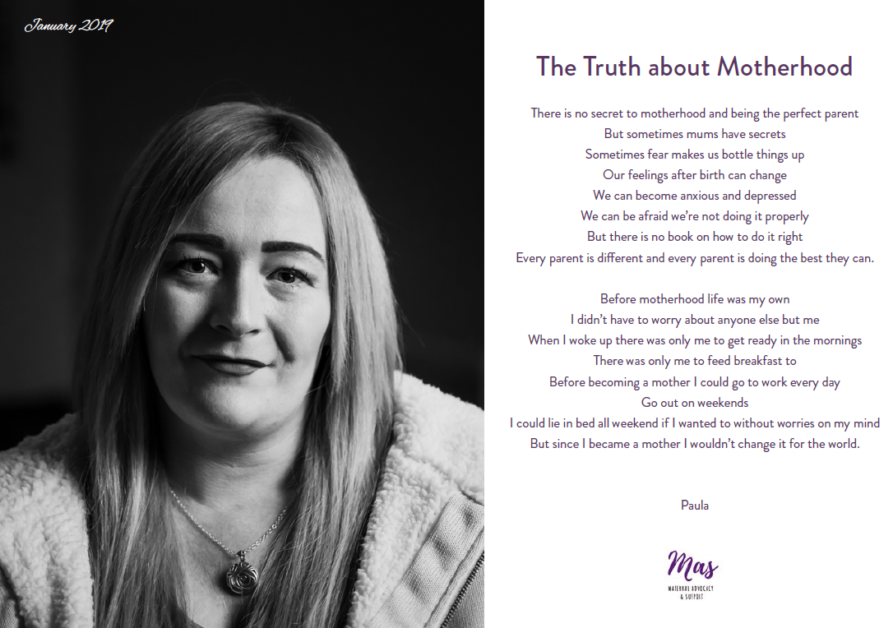
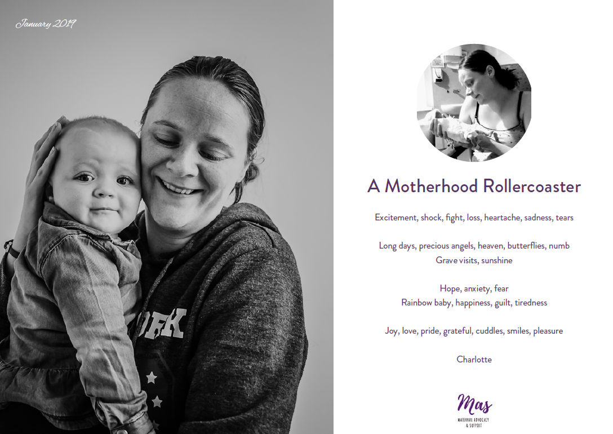
Participants’ Voices in Decision Making:
In addition to the meeting with the Chief Medical Officer and the workshop with midwives in the Royal, we also produced a short report outlining the views and recommendations gathered during the four ‘feedback for service providers’ focus group sessions held in January. This report has been disseminated to stakeholders in Northern Ireland and has been submitted as evidence to the recent Nursing and Midwifery Council’s ‘Future Midwife’ consultation on training and national standards for midwives.
Mas participants were asked to discuss their experiences of the main healthcare service providers they came into contact with in the perinatal period, with a focus on midwives, GPs and health visitors. They shared their views on what works well and what could be done better to identify and support women with perinatal mental health concerns. This is intended to provide constructive feedback to those working in statutory services. Some of the issues highlighted are systemic and require policy change and significant investment to ensure services are well staffed and resourced. Other issues point towards things that could easily be improved through training and raising awareness of the impact of the behaviour of different professionals on vulnerable mums.
This report is included in Appendix 2.

Conclusions and Key Learning
The purpose of piloting the Mas project was to engage women in the community in the process of designing a longer term perinatal mental health peer support project. Participants were aware from the beginning of the project that it was a pilot and therefore had limitations in terms of what could be delivered. It has been through their reflections on the experience and feedback that we can now develop a proposal for the next phase of this work. At the heart of the pilot project we were also testing a central hypothesis; that women’s centres provide the ideal structure, environment and value base for delivering maternal mental health peer support with women in disadvantaged communities. The feedback from participants, women’s centres and other stakeholders affirms the following conclusions and key learning that we will take forward into developing a proposal for the next phase of the Mas Project.
The women’s centres’ holistic model of feminist community development works.
It is clear that the women’s centres were ideally placed to recruit women to the Mas Project through their long-standing relationships and trust within their communities, which encouraged women to participate in something that has a significant level of stigma attached to it. Every group told stories of stigma, the fear of judgement from statutory agencies and the particular experience of facing additional barriers or stereotypes due to social class. Some women’s centres were concerned at the start of the project that this stigma and fear might put women off engaging at all but found that the setting and the way the programme was presented meant this was quickly overcome. One centre manager remarked,
“I was keen that we use positive language rather than talking too directly about ‘mental health issues’ as women are afraid of being seen to be struggling. But now I look at the group and how keen they are to come every week, wearing their Mas badges and feeling proud to be part of this and I am pleasantly surprised.”
It is also evident that women coming through the Mas Project have gone on to receive follow up support and engage in other services with help from the lead project worker in each centre. This includes helping mums get access to childcare hours, getting them into walk-in counselling services operating in the women’s centre, or finding them a place in other social support groups. It is important to note that this follow up work involves a significant time commitment from women’s centre staff and so this must be factored in to any proposals for future work. One to one support offered from the women’s centre would also need to continue during periods when the formal programme is not running and in fact becomes even more important during those times.
Social inequality matters.
We set out to examine the intersecting influence of gender and social inequality through this project, with support from Psychologists for Social Change. As their facilitator opened up discussions with the Mas groups about how women in disadvantaged communities experience these inequalities, it quickly became clear that women have something important to say. The groups discussed social factors like welfare cuts, job insecurity and shrinking services in the voluntary sector as things that compound their experiences of poor mental health. They also gave feedback about how statutory service providers can get things wrong or misinterpret their mental health and attempts to seek support, partly based on what appear to be stereotypes or assumptions regarding social class. A central message from the participants was that they see their perinatal mental health journey as connected to other factors in their lives including past trauma or abuse, grief and bereavement that they didn’t get adequate support to process, experiences of domestic violence, or poverty that is compounded by the state sanctioned vilification of them as women in receipt of benefits. The findings of the focus groups and the analysis from Psychologists for Social Change point towards the fact that this kind of work in areas of social disadvantage has a unique contribution to make to wider campaigns for better perinatal mental health services.
Peer support and advocacy helps women to progress at all stages of their journey.
The combination of peer support and advocacy in the Mas Project created a natural pathway for women at different stages of their perinatal mental health journey to find the best role for themselves. Some of the mums who came to Mas during pregnancy or with very young babies were most in need of the regular social support that Mas offered. One participant noted,
“This group is my lifeline. This is literally the only activity I have been able to stick at. Mas is the only reason I have a shower and get myself out of the house. Now that I’ve done this I know I don’t have to be so isolated.”
Some other participants with slightly older babies talked about feeling that they had perinatal mental health issues that are still unresolved and they valued the tools and activities such as the Aware NI Mood Matters class in order to help them work through those issues. For others who were further on in their recovery from perinatal mental health problems or who had already availed of counselling or treatment, the advocacy side of the project became a central focus. These mums were passionate about telling their stories now that they had moved far enough along to be able to process their experiences, and were energised by being able to help improve things for other women.
The success of the Mas Project lay in the fact that all of those aspects were able to exist together with opportunities for participants to engage with each part to the degree that they felt comfortable with. Some feedback from participants suggests that the balance was not always achieved for all of the groups we worked with and so any future Mas work would need to regularly monitor this and check that it is meeting the different needs and aspirations of all participants. A longer term project could also build in development opportunities such as training women with lived experience as peer supporters or in campaigning skills. One participant also suggested that we support women to train as mental health advocates, allowing them to accompany other women to appointments if they feel they need support in articulating their needs.
Appendix 1
Impact Report by Psychologists for Social Change NI
August 2019
The Maternal Advocacy Support (Mas) Project
Devised and implemented by the Women’s Resource and Development Agency (WRDA)

Context
Structural inequalities occur when one category of people are attributed an unequal status in relation to other categories of people, through unequal relations in roles, decisions, rights, and opportunities. This refers specifically to the inequalities that are systemically rooted in the normal operations of dominant social institutions. The Mas project was designed by WRDA to address structural inequalities, reaching out to women who are raising infants at a time when almost a decade of austerity has taken a massive toll on communities. These women are particularly under-served in the current climate, as neoliberal political agendas are reversing previous improvements in women’s rights and decimating state support for struggling families. For Northern Irish mothers, these challenges are being heaped on top of the issues experienced by post-conflict societies, such as increased suicide rates and the unfolding of transgenerational effects of trauma. Currently there is a new era of emerging political uncertainty, which adds to the stresses and challenges faced by our communities. Several structural inequalities are addressed by this project, including wealth inequality and gender inequality. This project is also mindful of the stigma attached to severe emotional distress and the marginalisation of those deemed mentally unwell.

The impact of wealth inequality on the wellbeing of mothers is substantial. Mothers from less wealthy areas are four times more likely to suffer from ‘postnatal depression’ (Marmot 2010). Austerity has led to increased poverty in the UK, and families with children have been hardest hit by austerity cuts (Padley et al 2015). An additional psychological adversity faced by mothers from deprived areas, is that the rhetoric used to push through austerity policies has promoted the idea that people in financial hardship are to blame for their circumstances (McGrath et al 2015).This leads to harmful psychological impacts such as feelings of shame and fear. Isolation has also been increased through impacts such as the closure of Sure Start centres, and isolation has been shown to increase mental health difficulties and inhibit recovery (Warner 2000). McGrath et al (2015) also highlight the compounding effects of cuts to legal aid and domestic violence shelters, leaving women and children at risk of further harm and feeling trapped and powerless.
Austerity has also led to an increase in the number of children and families subject to Child Protection Plans (Bilson & Martin 2016), and there has been an increase in the use of child protection interventions based on a concern about ‘neglect’ as oppose to physical harm. An area of high deprivation is a neighbourhood that has a lack of access to important resources such as income, education, employment and health. Children in the most deprived areas of the UK are eleven times more likely to be removed from their parents care (Bywaters 2017). Despite this, poverty is not considered within Social Work practice and policy, and so parents are blamed for the problems their children encounter, regardless of the parents’ psychological needs and their social contexts (Gupta, 2018). The language of ‘family support’ has all but disappeared and need is reframed as ‘risk’. This has led to a situation where families who are struggling fear rather than seek help from services (Featherstone et al, 2014).
The biomedical definition of mental illnesses such as ‘postnatal depression’, can have the adverse effect of obscuring the meaningful links between experiences of oppression and adversity and severe emotional distress. It also obscures the survival function of mental health ‘symptoms’ and reduces a sense of agency and hopefulness (Johnstone & Boyle 2018). Despite well-meaning anti-stigma campaigns aimed at equating mental illness to physical illness, as long as we deem some in society as suffering from a mental illness and see this as separate from ordinary human distress and unrelated to unmet human needs, the stigma will not be addressed. The use of a primarily medical response to emotional problems causes particular problems for mothers. Psychological research has found links between ‘postnatal depression’ and adverse effects on child development, however this ignores the social contexts that lead to disadvantage for mothers and babies, and the role of wider society and public services in creating safe and nurturing environments for young children. Even psychological treatments for mental health problems are affected by wealth inequality, with evidence showing that Cognitive Behavioural Therapy is effective for those living in wealthy areas, but less so for those in areas of high economic deprivation (Moloney & Kelly 2004),
Gender inequality is a societal issue that is reflected within the identification and response to serious emotional distress. Several mental illnesses are more often diagnosed in women, such as depression. This has been explained by an increased incidence of childhood sexual victimisation and sociocultural roles with an overload of responsibility and restricted choice and freedom (Piccinelli & Wilkinson, 2000). This review of the literature on depression and gender also found that hormonal differences were insignificant compared to environmental causes for increased depression in women compared to men, and genetic and neurochemical differences do not explain increased levels of depression in women. Even with increasing gender equality, women continue to be expected to undertake a greater share of parental responsibility, and our society confers a lower status to the child-rearing role, even compared to paid work that has an indiscernible contribution to society (Feder-Kitty & Feder, 2002). The tendency to medicalise distress experienced by women and ignore links to adversities such as domestic violence has been termed ‘mother-blaming’ (Woollett and Phoenix 1997). Miller and McClelland (2006) describe this as ‘the double-blind of traditional motherhood roles within heterosexual relationships - a lack of power and access to resources, combined with full responsibility for childcare, exposure to violence, lack of childcare support, and the psychological and emotional costs of caring’. In 1984, Naire & Smith contended that women’s depression is a feminist issue that needs to be viewed as a political and public problem rather than as a personal and private secret, however this insight is very different from the message we are sending to women in our communities who are struggling with significant emotional distress.
Our evaluation of the Mas Project Pilot Programme
The Review of Perinatal Mental Health Services in NI (RQIA, 2017) recommends the development of community based peer support services, service user input and facilitation of peer groups. WRDA should be commended for designing a project that has taken a significant step in delivering on this recommendation, despite a delay in implementation due to the current political stalemate in Northern Ireland.
WRDA were responsive to the needs and views of participants from the outset, identifying through discussions with workers in the Women’s Centres that the stigma of mental illness was a potential barrier to engaging with women who used the centres. The project achieved a balance between opening up a discussion about issues such as depression while providing a safe context where individuals did not feel under scrutiny and benefitted from sharing stories of problems and solutions as peers.
This project utilised a capacity building approach, which meets the needs of our communities in a way that demonstrates mutual respect and a desire to understand issues from the vantage point of those who are living through it. Capacity building projects aim to strengthen the skills, competencies and abilities of people and communities in local grassroots movements so they can achieve their goals and potentially overcome the causes of their exclusion and suffering. This approach provides peer support and meaningful service user engagement. As well as collaborating with several key stakeholders, this project enabled participants to voice their experiences and views to service providers and local representatives. The Mas Pilot Project included a creative use of media in engaging the participants in co-creating the recording of their experiences and views. While the participants were giving of their time freely to contribute to the future development of maternal mental health services, they were provided with holistic wellbeing interventions, including a CBT-based group session for tackling depression and anxiety. This was provided by a community based organisation in a group format which allowed the women to experience a sense of shared experience rather than individual deficit or failure to cope.
The supportive atmosphere and the interest shown in the participants’ views enabled the women to talk about fears of social service intervention, and how this prevents mothers with emotional difficulties from seeking assistance from services. This is an issue of paramount importance, which is not reflected in the recommendations from the review completed by RQIA in 2017, but it is an outcome of the recommendation to have service user input into future developments in services for maternal mental health. Psychologists for Social Change contributed a session to each group in the pilot programme which informed the participants of pertinent information regarding wealth inequality and gender inequality as significant in the wellbeing of mothers and their children.
Outcomes in relation to participant wellbeing
The Warwick Edinburgh Mental Wellbeing Scale (WEMWBS) is a brief questionnaire used to measure mental wellbeing in the general population. The scale has been widely used nationally and internationally for monitoring, evaluating projects and programmes and investigating the determinants of mental wellbeing (Stewart-Brown et al 2011).
27 participants completed the WEMWBS at the start of the pilot programme in September 2018.
Table 1: Wellbeing scores at the start of the pilot programme

The above chart shows that over half of the respondents (59%) scored below the cut-off point indicating possible or probable depression. This gives an indication of the level of need in the group of women that this project has the potential to reach.
Of the 27 initial respondents,13 completed the WEMWBS at the end of the pilot programme in March 2019. The small data set does not allow for statistical analysis, however it is possible to look at the range of wellbeing scores and how they change over time for 13 of the participants.

Table 2: Proportion with scores indicating probable depression across time

The bar chart shows that of the 13 respondents who were scored on wellbeing at the start and end of the pilot project, a concerning level of 61% scored in a range indicating probable depression at the outset. However, by the end of the pilot project only 8% scored in the range indicating probable depression.
Preliminary results regarding changes in perceived social support are promising. The line graph below shows the change in perceived social support, measured at the start and end of the pilot programme using the Multidimensional Scale of Perceived Social Support (MDSPSS) (Zimet et al 1988). The MDSPSS measures perceived social support from family, friends and a significant other. The Mas groups will have offered an opportunity for friendships between peers to develop and for pre-existing friendships to be strengthened.

Table 3: Changes in Perceived Social Support

The Perceived Community Support Questionnaire (PCSQ) measures respondent’s sense of belonging to a larger community and feeling part of this larger community. This is an important element of social support that is often overlooked in the literature, with a great emphasis placed on social support within individual relationships and families. Perceived community support has been shown to predict reductions in levels of depression (Herrero & Garcia 2007). We do not have a large enough data set at this stage to carry out statistical analyses, but this can be carried out if the project is rolled out in the future. The line graph below shows overall there was some improvement in Perceived community support for the 13 respondents.
Changes in Perceived Community Support

Conclusions
The Mas project was devised by a grassroots community organisation, guided by feminist principles. The project is designed with Women’s Centres as main collaborators. Both WRDA and the Women’s Centres sought to involve participants in this project in a way that respected and validated the voice of lived experience and ensuring that the project was guided by participants own narratives. The project design centred on advocacy and capacity building. The outcomes have identified recognised issues in maternal mental health provision, while identifying other issues that have not been previously highlighted. The format also conferred a benefit to individual participants, providing both a supportive intervention, while collating service user views. We would anticipate that establishing Mas groups in the longer term would improve the wellbeing of the women who access their groups, as well as the wellbeing of their children, families and communities. The advocacy element of this project will be invaluable to ensuring meaningful service user involvement in the implementation of the Review of Perinatal Mental Health Services in Northern Ireland.

Written by Dr Anne Darcy, Specialist Clinical Psychologist, Psychologists for Social Change Northern Ireland.
References
Bilson, A., & Martin, K. (2016). Referrals and Child Protection in England: One in Five Children Referred to Children’s Services and One in Nineteen Investigated before the Age of Five. British Journal of Social Work, 47(3), 793–811.
Bywaters, P., Brady, G., Bunting, L., Daniel, B., Featherstone, B., Jones, C., Morris, K., Scourfield, J., Sparks, T., & Webb, C. (2017). Inequalities in English Child Protection practice under Austerity: A universal challenge? Child and Family Social Work, 23(1), 53-61.
Featherstone, B., White, S., & Morris, K. (2014). Re-imagining child protection: towards humane social work with families. Bristol: Policy Press.
Feder-Kittay, E. & Feder, EK. (2002) The subject of care: Feminist perspectives on dependency. New Jersey: Rowman & Littlefield
Gupta, A (2018) Punishing the Poor? Child welfare and protection under neoliberalism. Social Work and Society, 16:2,
Herrero, J. & Garcia, E. (2007) Measuring perceived community support: Factorial structure, longitudinal invariance, and predictive validity of the PCSQ. Journal of Community Psychology, 35:2, 197-217
Johnstone, L. & Boyle, M (2018) The Power Threat Meaning Framework: Towards the identification of patterns in emotional distress, unusual experiences and troubled or troubling behaviour, as an alternative to functional psychiatric diagnosis. Leicester: British Psychological Society.
Marmot, M (2010) Fair society, healthy lives. London: The Marmot Review
McGrath, Griffin, V. Mundy, E (2015) The psychological impact of austerity: A briefing paper. London: Psychologists for Social Change (Formerly Psychologists against austerity)
Miller, J & McClelland, L (2006) Social Inequalities Formulation: Mad, bad and dangerous to know. In Johnstone, L & Dallos R. Formulation in Psychology and Psychotherapy. Routledge
Moloney, P. & Kelly, P, (2004) Beck never lived in Birmingham: Why CBT may be a less useful treatment for psychological distress than is often supposed. Clinical Psychology, 34, 4-10
Naire, K. & Smith, G. (1984) Dealing with depression. London: The Women’s Press
Padley, M. Valadez, L. Hirsch, D. (2015) Households below a minimum income standard. London: Joseph Rowntree Foundation.
Piccinelli, M. & Wilkinson, G. (2000) Gender Differences in depression. British Journal of Psychiatry, 177, 486-492
RQIA (2017) Review of Perinatal Mental Health Services in Northern Ireland. The Regulation and Quality Improvement Authority.
Stewart-Brown, S. L., Platt, S., Tennant, A., Maheswaran, H., Parkinson, J., Weich, S. & Clarke, A. (2011). The Warwick-Edinburgh Mental Well-being Scale (WEMWBS): a valid and reliable tool for measuring mental well-being in diverse populations and projects. Journal of Epidemiology and Community Health, 65(Suppl 2), A38-A39.
Warner (2000) The environment of schizophrenia: Innovations in policy, practice and communications. London: Brunner-Routledge
Zimet, G.D., Dahlem, N.W., Zimet, S.G. & Farley, G.K. (1988). The Multidimensional Scale of Perceived Social Support. Journal of Personality Assessment, 52, 30-41.

Appendix 2
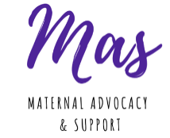
Women’s Views on Health Service Support in the Perinatal Period
Introduction:
This report is the result of a series of facilitated discussions with women taking part in the Mas Project. Mas, Maternal Advocacy and Support, is a pilot peer support programme that ran for 6 months from September 2018 to March 2019 in 5 women’s centres and was supported by Belfast City Council. The project was facilitated by Women’s Resource and Development Agency and focuses on addressing issues associated with perinatal mental health. The Mas project brought women together in Shankill, Windsor, Greenway, Ballybeen and Footprints Women’s Centres to participate in workshops, meet other mums and share their experiences of the support that is available. They also engaged with existing campaigns on perinatal mental health services such as the ‘Everyone’s Business’ campaign which is calling for a specialist mother and baby mental health unit and perinatal mental health specialists in every trust.
Twenty-four women participated in the project and during four facilitated discussions they gave their views on the support available to mums in the perinatal period and why they believe many women are not getting the mental health help they need. This report sets out those views in detail. The participants were concerned about the nature of training for key service providers such as midwives and GPs on perinatal mental health and they would like to see mandatory training in place that every service provider must attend. Also of concern is the pressure put on NHS services due to lack of funding which these women believe is having an impact on vulnerable mums. They are calling for greater consistency in the care provided to women during pregnancy and after so that they have time to build up trust with service providers and speak up about their mental health struggles. In addition to this feedback for health service providers, the group is calling for resources for long term support in the community such as counselling, peer support groups and access to practical support like free childcare places. They are highlighting the crucial role women’s centres play in providing these kind of holistic services with very little funding.
The Mas Project has been supported by a range of organisations such as Aware NI, Sure Start, Parenting NI and Mencap who all got involved in the workshops. They are also pleased to have had a number of health service providers and policy makers attend their showcase event and request follow up meetings. They intend to engage in ongoing advocacy and campaigning to seek the improvements that they think are necessary. Their key message will be that they have waited long enough for action and they want to see changes immediately as women’s lives depend on it.

General comments:
Participants tended to attribute their positive experiences of health service providers to the personal characteristics of the individual service provider. They talked about having a brilliant midwife, health visitor or doctor who had the personality for the job, was caring, listened to them, and was clearly committed to helping them. Conversely, people were more likely to attribute negative experiences to problems with the system such as midwives in hospitals who are clearly under too much pressure with not enough staff or GP waiting lists making it hard to get access or time with a doctor.
In reality it’s likely that the balance falls somewhere in between both. The whole system is under resourced and those healthcare providers who are doing an excellent job are doing so in spite of the immense pressure they are under. However, the actions, words or attitudes of some individuals have had a negative impact on some mums who are struggling and this needs to be acknowledged.
During the facilitated discussions we talked about the journey through the health service when you’re having a baby and discussed experiences of the service providers you engage with at each step.
Midwives
- As already noted, the pressure on staff, particularly in the hospital setting, is felt by mums. They did not feel that midwives have enough time to help each person and some felt they were left alone for long periods of time either in labour with no one checking their progress, or after their baby was born.
- We had some discussion about how seriously women are taken during labour and how this experience impacts on their self-esteem. If you feel that you’ve not been listened to or taken seriously during that period when you’re very vulnerable it can lead you to be hesitant to speak up about things you’re struggling with after the baby arrives. We need to create a culture where women are supported to trust themselves and express their concerns in order for them to be able to identify and get help with perinatal mental health issues. Midwives have a major role to play in this by really listening to women from the start of their pregnancy, taking their fears seriously, acknowledging their pain, and respecting their knowledge about their own bodies.
- Self-esteem came up again as a theme in discussions around engagements with community midwives once you come home from the hospital. The key thing that was expressed was just how vulnerable you feel and how you are your own worst critic. Therefore any negative comments are hugely amplified and can have an impact far beyond what was intended. This was particularly important for people with pre-existing mental health conditions. One mum said that a critical comment made in those early days has become embedded in her head and still comes into her mind when she’s questioning herself and her ability to parent 6 years later.
- Feeding was a source of anxiety and feelings of guilt for a lot of our mums. Some had a lot of feelings of shame about not breastfeeding and so any conversations with midwives about this issue seemed like they were being judged. Others felt under pressure from midwives to introduce bottle feeds when what they were actually looking for was support to persevere with breastfeeding. I think an underlying theme for all these conversations was the need to really listen to mums and understand that the intense experience of feeding, however you do it, has a huge impact on your mental health.
- Most of our participants didn’t feel that midwives were there for them, just for the baby, and so they didn’t really develop any sense of connection. That lack of connection was also attributed to the fact that you see so many midwives in such a short space of time, often they all have conflicting advice for you, and it’s very hard to find any space in that process to raise issues that you’re having in terms of your own mental health.
- Participants felt that it would help if there was more consistency and you saw the same midwife throughout. Some suggested having a midwife whose role is to focus on you the mum in addition to those who are there for the baby.
- The current set of questions asked by midwives regarding mental health are not enough to identify problems. The standard question of ‘any low mood or crying’ felt to most participants like a ‘tick box’ exercise. Some who had experienced conditions other than depression felt there was no way for them to identify their symptoms. Anxiety for example cannot be properly identified using the current questions as it could include things like insomnia, racing heartbeat, nausea or panic attacks which none of the participants had been asked about.
Health Visitors
- A lot of people felt very positive about their health visitor. During some of the discussions people’s faces lit up when they said their health visitor’s name. This was particularly from those who’d had the same health visitor for all of their children. Some had even had the same health visitor as all of their family members. It’s clear that consistency in this relationship makes a difference to the sense of connection, trust and willingness to ask for help with your mental health. More mums felt that the health visitor was there for them and not just the baby, although not everyone had this experience. They also noted the role health visitors have played in their lives in terms of connecting them in with other services and support networks. This covers not just formal support but also being able to bring in family and friends because health visitors have a broader knowledge of your circumstances and your wider community.
- Some women felt that meeting the health visitor before the baby is born would help mothers feel more comfortable and confident about talking to them after baby comes.
- Some participants had negative experiences mostly attributable to the gaps in the system. We heard from people who appear to have been taken off the books when they move house and have never been contacted since. We had someone whose health visitor retired and wasn’t replaced so in the sharing out of clients to the rest of the team she fell through the cracks and was not allocated to anyone.
- We identified a major gap in provision for women who have experienced baby loss due to the story of one of our courageous mums who has a previous experience of losing two babies shortly after birth. While she had some contact with midwives in the early days she was never assigned a health visitor and feels like this does a great disservice to grieving mums. She noted that you have been through all the same experiences as other mums, the physical trauma of birth, the emotional impact of the experience, your body going through the normal hormonal reactions like milk coming in; but because you have come home without your baby you drop out of the system. It would be good if health visitors were assigned to visit these women and make sure that they are supported and get the chance to connect in with support services and networks.
- Having a health visitor who is contactable and can visit more often is important. Some women had experiences of not being able to get hold of their health visitor or having very infrequent visits. One young mum in our group had a really positive experience of the Family Nurse Partnership programme in North Belfast in terms of having someone who is always on the end of the phone if you are struggling. When maternal mental health issues are identified this consistency becomes even more important.
- It seems from our discussions that the old stereotype of the health visitor coming to inspect your house and criticise you is no longer prevalent. We heard lots of our participants saying they got very reassuring messages from their health visitor, and we were pleased to have a couple of health visitors attend our groups in Windsor Women’s Centre and Footprints. Interestingly, one of them noted that it is often the mums who don’t ask for help that she worries about the most, those who seem to be struggling but won’t talk about it. It would be great if we could work on addressing all the factors that lead to some women still keeping their mental health struggles inside.
GP Services
- As it often takes so long to get an appointment with your GP, many mums are putting off dealing with their mental health symptoms and prioritising their child’s health needs instead when choosing what issues to take to their GP.
- We know that GPs are essential to the pathway of getting help, whether that’s an individual self-referring or a health visitor making a referral. Once in that room, our participants had mixed experiences. Some felt their GP gave them time and was open to talking about maternal mental health. Some felt the actions their GP had taken had saved their lives. However some also reported GPs not responding in a very effective way. Some felt that the GP didn’t really understand perinatal mental health, asked unhelpful questions or played down their concerns. A common experience was being given a leaflet to go away and read which most people found was relatively useless. If there was a word that could sum up some of the more negative experiences it would be ‘gatekeeping’; a sense that you had to prove yourself to your GP in order to access help. One woman said ‘you’d have to have a complete breakdown in their office before they’d take you seriously’. Another was supporting a friend whose abiding memory from her consultation with her doctor on feeling suicidal was that she mustn’t be that bad because she was wearing makeup. We believe there is a need to have a serious conversation about the presence of bias and stereotyping on the basis of gender and social class.
- Some participants noted how quickly medication was offered without much exploration of whether or not that would be the best approach. Very few were offered a referral for talking therapies and most people who did want that had to go back to their GP and specifically ask for it. Some had experienced long waiting lists for counselling and felt that was why doctors were quicker to present medication as a course of action.
- Given our focus on social inequality we are working from the assumption that most mums would not have the luxury of being able to spend £40 or £50 per hour on private counselling. Due to the restricted access to counselling that GPs can offer there is a great reliance on other community based services to fill that gap. Some had used the free counselling available in their women’s centre. Others had ongoing support from a CPN which was helpful.
- There was some discussion about the fact that many surgeries now have a greater reliance on locum doctors. Opinion was split on this with some participants feeling that a locum is more likely to refer you on to mental health services because they are more worried about getting it wrong. But some felt it takes a family doctor who knows your background to really understand your mental health needs.

Family Support Services
We had the opportunity to engage with family support workers through both Sure Start and the Family Support hubs and heard great examples of how these services have played a positive role for many of our participants. There was some concern that the phrase ‘family support’ has become connected with an assumption that you are a ‘troubled family’ or that as a parent things are not going well. While family support aims to be a preventative service open to all families in the community, it did prompt some discussion about how the service is promoted and some steps that might help mums overcome a sense of stigma when it comes to asking for help. One participant raised the issue of trust with family support workers as she had an incident of a family support worker talking to her social worker without first communicating her concerns and discussing them directly. The role of the family support work is clearly a complex one in terms of building trust but also being alert to safeguarding issues. Our participants felt the most important aspect of balancing this role is open communication with mums.
Final Comments
As noted at the start of this report there were some broad lessons across all these services. One thing that came up across the board was the ongoing issue of stigma. No matter which service provider you choose to talk to about your mental health, the conversation inside your head that tells you to be ashamed of what you’re feeling is always there. Fighting stigma is not just about encouraging people to speak up and ask for help, it’s also about making it easier for them to do that. Many of our groups expressed very real concern about a mental health issue triggering social services involvement. We think socio-economic background is connected to these experiences because of the compounding impact of things like welfare reform, and job and housing insecurity. We’ve explored through our work with Psychologists for Social Change the fact that contextual issues like social and economic inequality, community infrastructure, conflict and trauma all have to be taken into account when supporting people with their mental health. It is vital that socio-economic background does not end up leading to additional barriers to mums seeking and getting help with perinatal mental health concerns.

5th April 2019

